**Tema laborator 3 SGBD**

**E2 A.**

-- E2

-- a.

WITH OCTOMBRIE AS (

SELECT

TO_DATE('2024-10-01', 'YYYY-MM-DD') + LEVEL - 1 AS ZI

FROM DUAL

CONNECT BY LEVEL <= 31

)

SELECT

TO_DATE(OCT.ZI),

COUNT(R.BOOK_DATE)

FROM OCTOMBRIE OCT

LEFT JOIN RENTAL_LBC R ON EXTRACT(DAY FROM OCT.ZI) = EXTRACT(DAY FROM R.BOOK_DATE)

AND EXTRACT(MONTH FROM BOOK_DATE) = 10

GROUP BY OCT.ZI

ORDER BY OCT.ZI;

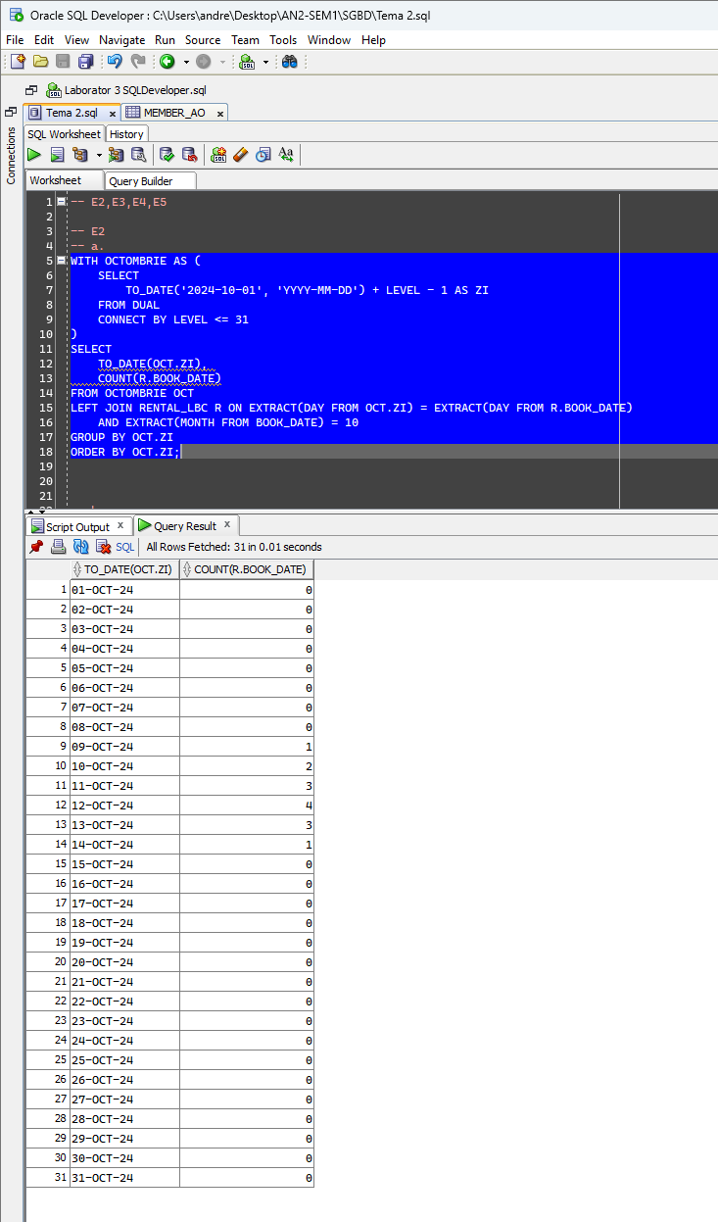

**E2 B.**

-- b.

CREATE TABLE OCTOMBRIE_AO(

ID INT PRIMARY KEY,

DATA DATE NOT NULL

);

-- POPULARE UTILIZAND PL/SQL

DECLARE

AUX DATE;

BEGIN

FOR CONT IN 1..31 LOOP

AUX := TO_DATE('2024-10-' || TO_CHAR(CONT), 'YYYY-MM-DD');

INSERT INTO OCTOMBRIE_AO (ID, DATA) VALUES (CONT, AUX);

END LOOP;

COMMIT;

END;

/

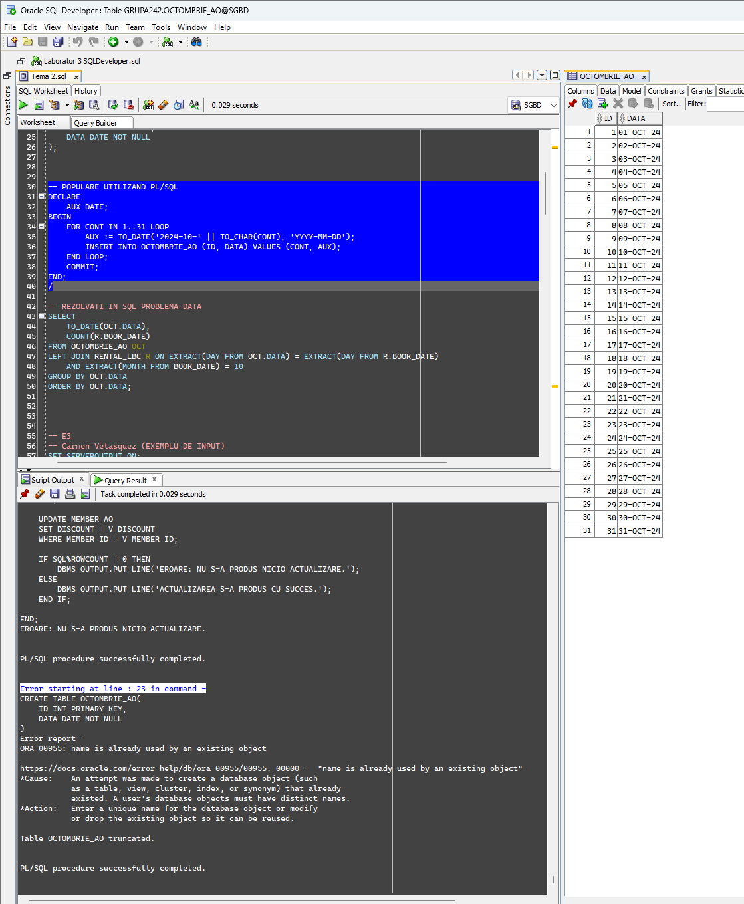

-- REZOLVATI IN SQL PROBLEMA DATA

SELECT

TO_DATE(OCT.DATA),

COUNT(R.BOOK_DATE)

FROM OCTOMBRIE_AO OCT

LEFT JOIN RENTAL_LBC R ON EXTRACT(DAY FROM OCT.DATA) = EXTRACT(DAY FROM R.BOOK_DATE)

AND EXTRACT(MONTH FROM BOOK_DATE) = 10

GROUP BY OCT.DATA

ORDER BY OCT.DATA;

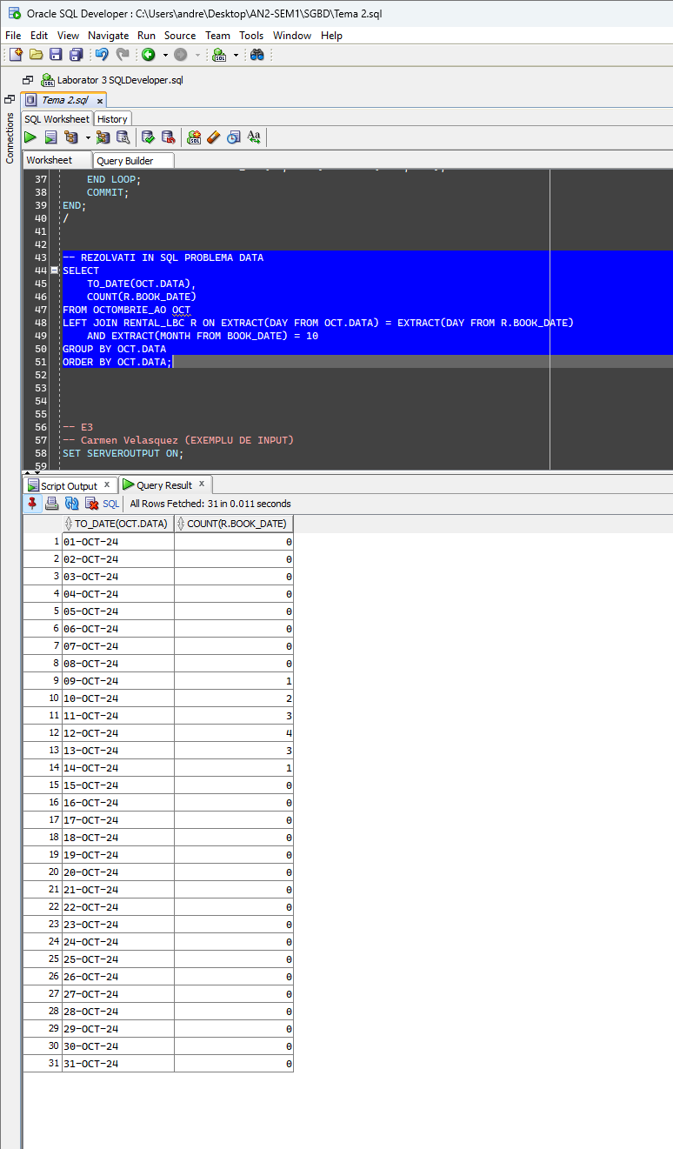

**E3**

-- E3

-- Carmen Velasquez (EXEMPLU DE INPUT)

SET SERVEROUTPUT ON;

DECLARE

V_FIRST_NAME VARCHAR2(100) := '&V_FIRST_NAME';

V_LAST_NAME VARCHAR2(100) := '&V_LAST_NAME';

REZ NUMBER(6);

V_CONT_FIRST_NAME NUMBER(6);

V_CONT_LAST_NAME NUMBER(6);

BEGIN

SELECT

COUNT(*)

INTO REZ

FROM RENTAL_LBC R

JOIN MEMBER_LBC M ON M.MEMBER_ID = R.MEMBER_ID

WHERE UPPER(M.FIRST_NAME) = UPPER(V_FIRST_NAME) AND UPPER(M.LAST_NAME) = UPPER(V_LAST_NAME);

-- VERIFICARE CATI MEMBRI AU PRENUMELE CITIT DE LA TASTATURA

SELECT

COUNT(*)

INTO V_CONT_FIRST_NAME

FROM MEMBER_LBC M

WHERE UPPER(M.FIRST_NAME) = UPPER(V_FIRST_NAME);

-- VERIFICARE CATI MEMBRI AU NUMELE CITIT DE LA TASTATURA

SELECT

COUNT(*)

INTO V_CONT_LAST_NAME

FROM MEMBER_LBC M

WHERE UPPER(M.LAST_NAME) = UPPER(V_LAST_NAME);

IF V_CONT_FIRST_NAME = 0 OR V_CONT_LAST_NAME = 0 THEN

DBMS_OUTPUT.PUT_LINE('NU EXISTA MEMBRI CU NUMELE DAT.');

ELSIF V_CONT_FIRST_NAME != 1 AND V_CONT_LAST_NAME != 1 THEN

DBMS_OUTPUT.PUT_LINE('NU SE POATE AFISA NUMARUL DE IMPRUMUTURI PENTRU CA EXISTA MAI MULTI MEMBRI CU ACELASI NUME.');

ELSE

DBMS_OUTPUT.PUT_LINE('NUMARUL DE TITLURI IMPRUMUTATE DE CATRE ' || V_FIRST_NAME || ' ' || V_LAST_NAME || ' ESTE: ' || REZ);

END IF;

END;

/

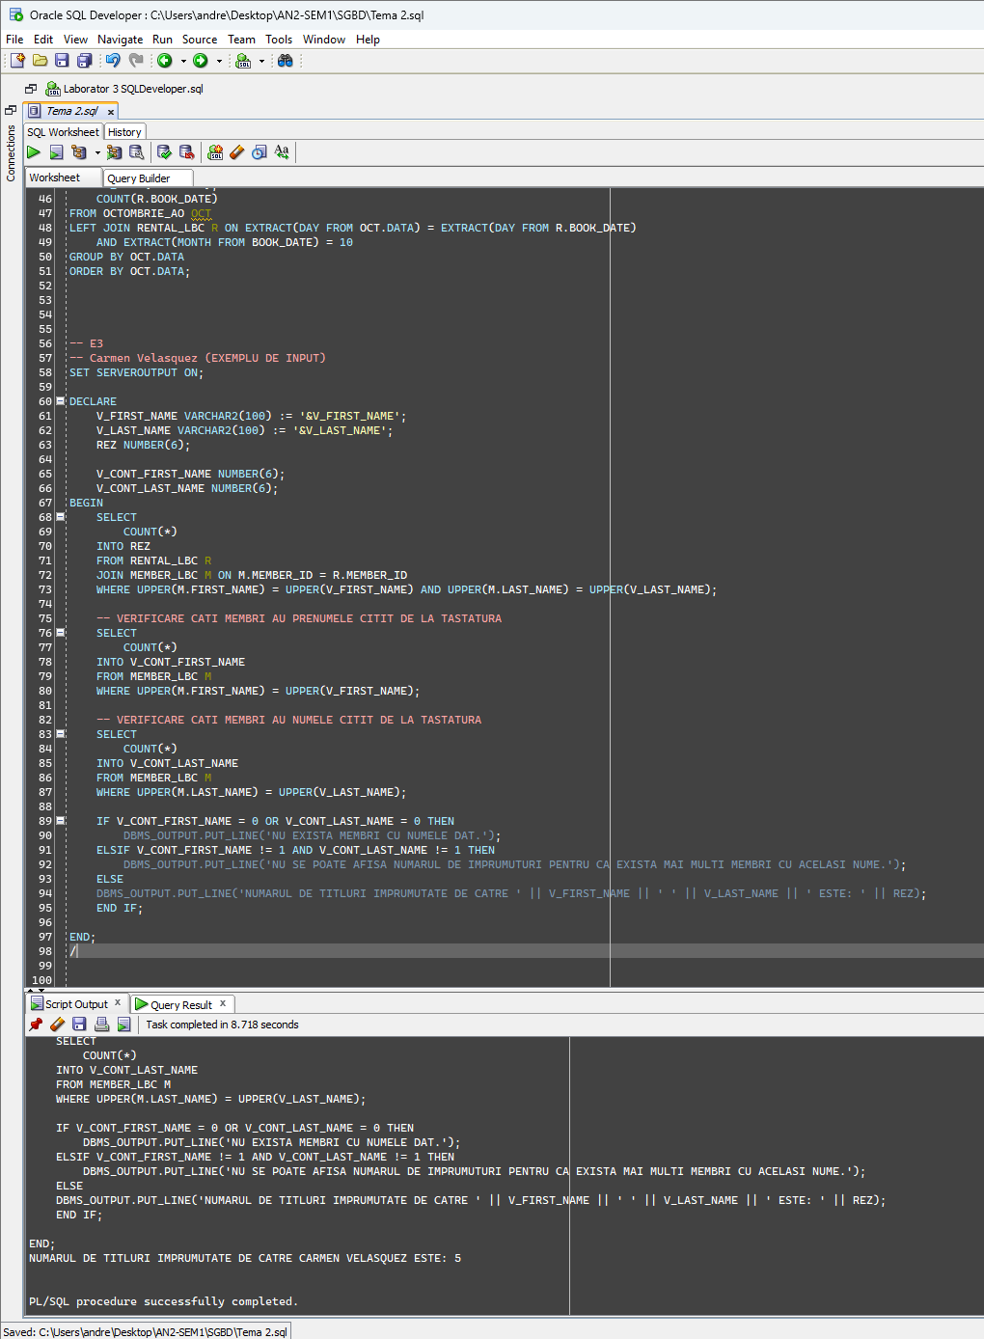

**E4**

-- E4

-- Carmen Velasquez (EXEMPLU DE INPUT)

SET SERVEROUTPUT ON;

DECLARE

V_FIRST_NAME VARCHAR2(100) := '&V_FIRST_NAME';

V_LAST_NAME VARCHAR2(100) := '&V_LAST_NAME';

REZ NUMBER(6);

V_CONT_FIRST_NAME NUMBER(6);

V_CONT_LAST_NAME NUMBER(6);

V_TITLURI NUMBER(6);

V_RAPORT NUMBER;

V_CATEGORIE VARCHAR(5);

BEGIN

-- EXTRAGERE NUMAR DE IMPRUMUTURI

SELECT

COUNT(*)

INTO REZ

FROM RENTAL_LBC R

JOIN MEMBER_LBC M ON M.MEMBER_ID = R.MEMBER_ID

WHERE UPPER(M.FIRST_NAME) = UPPER(V_FIRST_NAME) AND UPPER(M.LAST_NAME) = UPPER(V_LAST_NAME);

-- VERIFICARE CATI MEMBRI AU PRENUMELE CITIT DE LA TASTATURA

SELECT

COUNT(*)

INTO V_CONT_FIRST_NAME

FROM MEMBER_LBC M

WHERE UPPER(M.FIRST_NAME) = UPPER(V_FIRST_NAME);

-- VERIFICARE CATI MEMBRI AU NUMELE CITIT DE LA TASTATURA

SELECT

COUNT(*)

INTO V_CONT_LAST_NAME

FROM MEMBER_LBC M

WHERE UPPER(M.LAST_NAME) = UPPER(V_LAST_NAME);

-- EXTRAGERE NUMAR TITLURI

SELECT

COUNT(T.TITLE_ID)

INTO V_TITLURI

FROM TITLE_LBC T;

IF V_CONT_FIRST_NAME = 0 OR V_CONT_LAST_NAME = 0 THEN

DBMS_OUTPUT.PUT_LINE('NU EXISTA MEMBRI CU NUMELE DAT.');

ELSIF V_CONT_FIRST_NAME != 1 AND V_CONT_LAST_NAME != 1 THEN

DBMS_OUTPUT.PUT_LINE('NU SE POATE AFISA NUMARUL DE IMPRUMUTURI PENTRU CA EXISTA MAI MULTI MEMBRI CU ACELASI NUME.');

ELSE

DBMS_OUTPUT.PUT_LINE('NUMARUL DE TITLURI IMPRUMUTATE DE CATRE ' || V_FIRST_NAME || ' ' || V_LAST_NAME || ' ESTE: ' || REZ);

-- CALCULARE CATEGORIE

V_RAPORT := REZ / V_TITLURI;

V_CATEGORIE :=

CASE

WHEN V_RAPORT > 0.75 THEN '1'

WHEN V_RAPORT > 0.50 THEN '2'

WHEN V_RAPORT > 0.25 THEN '3'

ELSE '4'

END;

DBMS_OUTPUT.PUT_LINE('MEMBRUL FACE PARTE DIN CATEGORIA: ' || V_CATEGORIE);

END IF;

END;

/

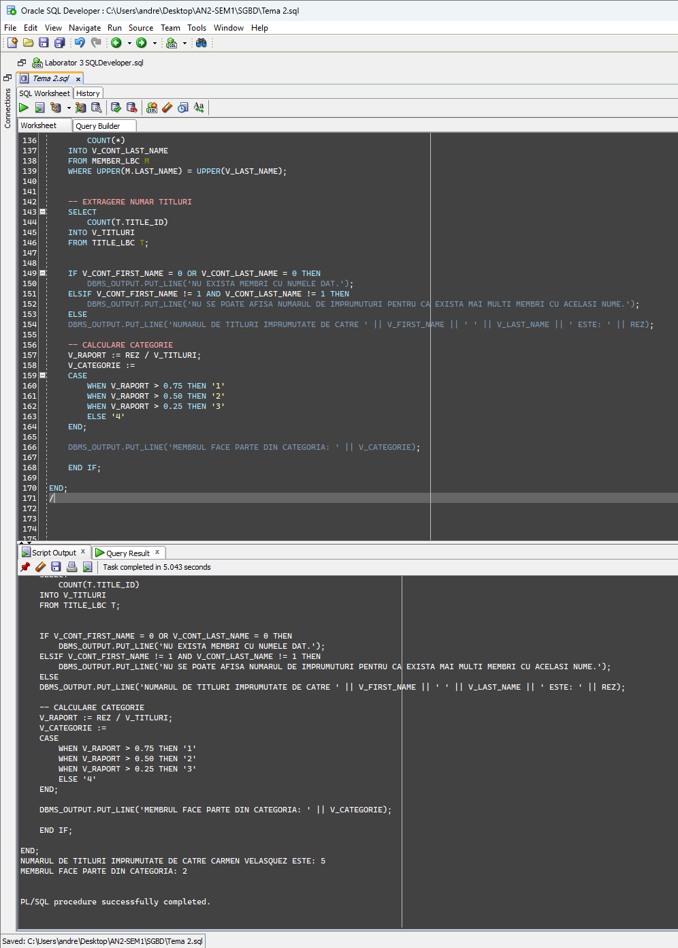

**E5 – PENTRU MEMBER_ID = 102**

-- E5

CREATE TABLE MEMBER_AO AS

SELECT *

FROM MEMBER_LBC;

ALTER TABLE MEMBER_AO

ADD DISCOUNT NUMBER(3, 2);

-- Actualizati coloana discount pentru un membru al carui cod este dat de la tastatura.

DECLARE

V_MEMBER_ID MEMBER_AO.MEMBER_ID%TYPE := &V_MEMBER_ID;

V_DISCOUNT MEMBER_AO.DISCOUNT%TYPE;

V_TITLURI NUMBER(6);

V_NUMAR_IMPRUMUTURI NUMBER(6);

V_RAPORT NUMBER;

BEGIN

-- EXTRAGERE NUMAR TITLURI

SELECT

COUNT(T.TITLE_ID)

INTO V_TITLURI

FROM TITLE_LBC T;

-- EXTRAGERE NUMAR DE IMPRUMUTURI ALE MEMBRULUI

SELECT

COUNT(*)

INTO V_NUMAR_IMPRUMUTURI

FROM RENTAL_LBC R

JOIN MEMBER_AO M ON M.MEMBER_ID = R.MEMBER_ID

WHERE M.MEMBER_ID = V_MEMBER_ID;

V_RAPORT := V_NUMAR_IMPRUMUTURI / V_TITLURI;

V_DISCOUNT :=

CASE

WHEN V_RAPORT > 0.75 THEN 0.1

WHEN V_RAPORT > 0.50 THEN 0.05

WHEN V_RAPORT > 0.25 THEN 0.03

ELSE NULL

END;

UPDATE MEMBER_AO

SET DISCOUNT = V_DISCOUNT

WHERE MEMBER_ID = V_MEMBER_ID;

IF SQL%ROWCOUNT = 0 THEN

DBMS_OUTPUT.PUT_LINE('EROARE: NU S-A PRODUS NICIO ACTUALIZARE.');

ELSE

DBMS_OUTPUT.PUT_LINE('ACTUALIZAREA S-A PRODUS CU SUCCES.');

END IF;

END;

/

**Inainte de rulare:**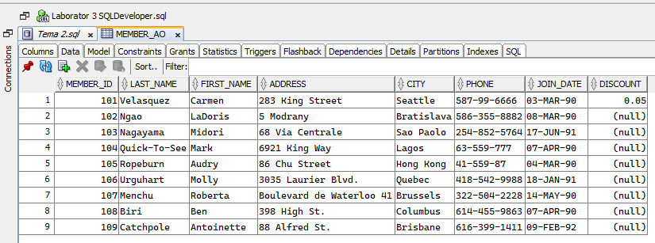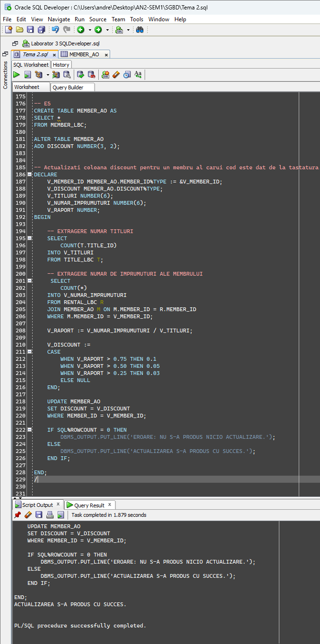

**Dupa rulare:**

